**YLDP Session with Dr. Renu Khator- University of Houston**

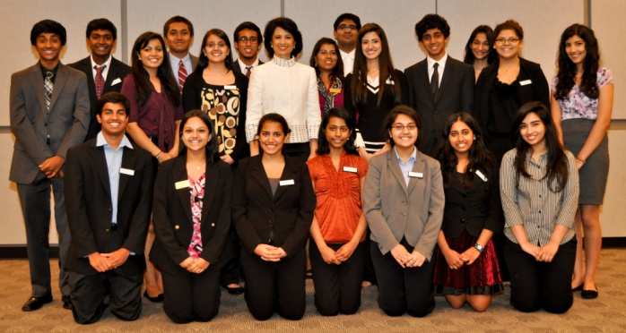

On April 28, Youth Leadership Development Program (YLDP) students visited an extraordinary woman, as she recounted her mission, obstacles, and journey to success. This lady, the president and chancellor of the University of Houston, Dr. Renu Khator, is the first Indo-American woman to serve as the president of an American university. In her speech, Dr. Khator imparted many lessons she believes are the foundations of leadership.

The first of these essential requirements is to have a wild dream, whether it is a little crazy or completely irrational. Dr. Khator explained to the students how her dream of earning a PhD faced difficulty when her traditional Indian family forced her into an arranged marriage. However, she managed to put herself through college and beyond, sticking to her crazy dream and made it a reality.

The second characteristic of effective leadership, according to Dr. Khator, is to act on one’s dream and never let anything obstruct its path. She described how after she transferred to the United States, she overcame a tough language barrier by watching eight hours of television everyday to immerse herself in the English language.

Dr. Khator’s final piece of advice for aspiring leaders is simple – be humble. She believes that “no leader travels alone” and that great leaders are defined by their humility.

Dr. Renu Khator’s success story teaches many other lessons as well as the three she focused on. Dr. Khator creates future goals to “build” upon-goals that she can keep working on throughout her career. In this way, she is able to perfect whatever she wants to accomplish because she is never completely finished with something.

We, as YLDP students and future leaders, learned from Dr. Khator’s lessons and incredible success story to make our journey towards our irrational dreams easier and even more successful.

Reported by YLDP students: Aditya Srinivasan, Raj Kavadi, Srimahesh Vangavolu, Isha Deo, Nicole Bhatnagar